Rahul Kishan

Software Engineer at PayPal

(Day 2)

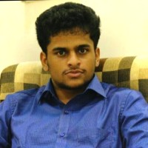

|  |
| --- |
| Dr Lalit Garg Computer Information Systems  Faculty of Information & Communication Technology  University of Malta, Malta  (Day 2 Keynote Speaker)    Ankit Bhagat  Founder of Nuclei Technologies  (Day 1 Conclave Panel Speaker) |